

Digital Grid Services Itential Workflows Best Practices (under development)

Date of the Document

2025-08-10

Prepared by:

Digital Grid Services

Document Version

1.0

Table of Contents

1. Introduction 3

Purpose 3

Scope 3

Audience 3

Objectives 3

2. Workflow Best Practices 4

2.1 Top-to-Bottom Design for Workflow Clarity 4

2.2 Descriptive Task Summaries 5

2.3 Job Variable and Assets Naming Convention 5

2.3.1 Workflow variables 5

2.3.2 Transformer Naming Conventions 5

2.4 Error Handling 6

2.5 Readme 6

2.6 ChildJob Object 6

3. BMC Helix and Itenial 6

## 1. Introduction

### Purpose

The Southern California Edison (SCE) Digital Grid Services (DGS) team has adopted the Itential toolset to address the inherent complexity of modern, distributed infrastructure. By leveraging advanced automation, orchestration, and large-scale management capabilities, Itential enables SCE to drive greater operational efficiency, strengthen agility, and optimize performance across diverse technology environments.

This document establishes best practices for designing, implementing, and maintaining Itential workflows within DGS. It serves as a reference to ensure consistency, scalability, and alignment with SCE’s broader digital grid transformation objectives (IT2.0).

### Scope

The best practices described herein apply to all DGS personnel (including the third-party partners) who design, operate, or support network and infrastructure automation using Itential. While the primary focus on the grid network environments, these practices may also be relevant to adjacent teams and external partners who depend on automated workflows and orchestration to deliver reliable and scalable outcomes.

### Audience

This document is intended for network engineers, telecom engineers, infrastructure engineers, cyber security, solution architects, and operations staff directly engaged in the deployment and maintenance of Itential workflows. It may also serve as a high-level reference for leadership, project managers, and stakeholders who oversee or support automation initiatives across SCE.

### Objectives

* Establish a standardized approach for implementing and managing Itential workflows across DGS.
* Promote consistency, modularity, and maintainability in automation design.
* Enhance operational efficiency, agility, and resilience within SCE IT2.0 goals.
* Support compliance, governance, and security requirements in line with enterprise standards.
* Facilitate collaboration, knowledge sharing, and continuous improvement across technical teams.

# 2. Workflow Best Practices

## 2.1 Top-to-Bottom Design for Workflow Clarity

Design workflows to flow vertically top to bottom (Waterfall style), with divergence handled right to left, and success or failure paths directed left to right. This orientation enhances readability and comprehension, especially for complex workflow. For example,

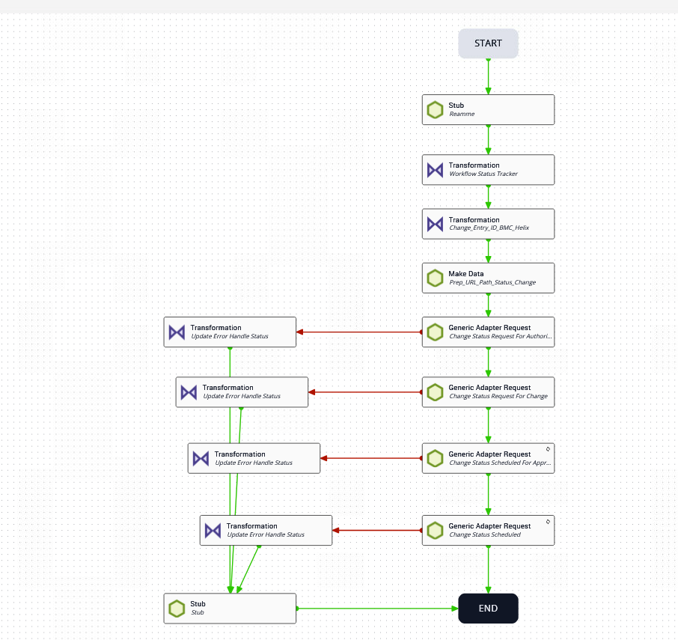

## 2.2 **Descriptive Task Summaries**

Treat task summaries and descriptions like code comments. Replace generic defaults with meaningful, contextual descriptions (e.g., “Query data using dot/bracket notation…” rather than “Query Workflow Names”). Use clear task names for better job visibility.

## 2.3 Job Variable and Assets Naming Convention

Establishes standards for managing job variables, handling child-to-parent workflow dependencies, and the naming convention for the objects in the Itenial workflow. To ensure consistency and alignment with industry-recognized practices, the SCE Digital Grid Services (DGS) team has adopted the **Industrial Naming Standard**, specifically **Upper Camel Case (Pascal Case)**, for all workflow objects. Camel case is a way to write multi-word identifiers in programming without spaces or hyphens, using capitalization to separate the words.

### 2.3.1 Workflow variables

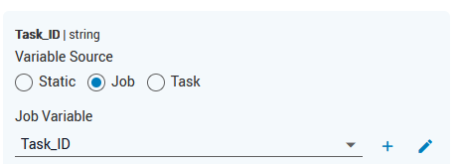

### 2.3.2 Transformer Naming Conventions

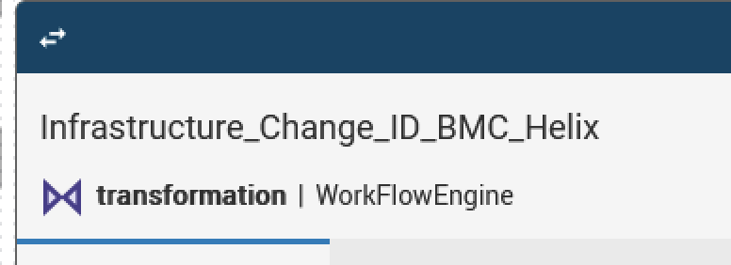

## 2.4 Error Handling

Using Work Status Tracker to handle to

## 2.5 Readme

## 2.6 ChildJob Object

# 3. BMC Helix and Itenial

BMC Helix is an enterprise IT service and operations management platform built by BMC Software. It’s widely used by large organizations (including utilities like SCE)